

Best Practices

Concierge Maintenance

Archiving Your Logbook

As soon as you begin using The Concierge Assistant you start adding entries to the Logbook. Over time the file grows and search results become unwieldy. To achieve maximum performance you should create a regular schedule for archiving your Logbook Entries. We recommend that the first person on duty on the first day of each month run the archive process on the Concierge Maintenance program. Please note that ALL users must have exited The Concierge Assistant program before the purge can begin.” (Please refer to our Best Practices document - “Check for Logged On Users”)

The “Current Database” section of the Concierge Maintenance program provides the features for archiving or purging the Current Database.

When you launch the Concierge Maintenance program the calendar combo-type box has a date equal to the first day of the current month.

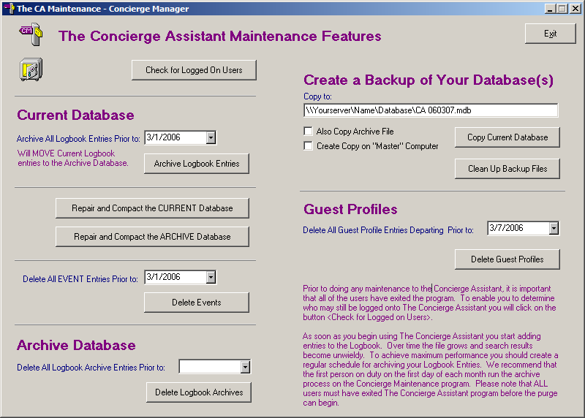

Now simply press the “Archive Logbook Entries” button.

.

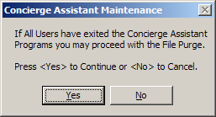
This screen will appear. Click on the “Yes” button after confirming that EVERYONE is exited out of The Concierge Assistant

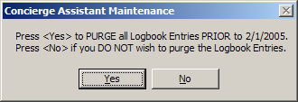
After you click the “Yes” button, this screen will appear asking for a confirmation of the Archive date.

When the archiving has been completed, the following dialogue box will appear telling you it is complete and remind you to Repair and Compact BOTH Databases.

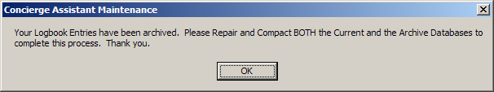

Click the “OK” button.

To Repair and Compact BOTH Databases; First, press the “Repair and Compact the CURRENT Database” and follow the prompts. When completed, click on the “Repair and Compact the ARCHIVE Database” button and follow the prompts to complete the process.

Logbook Entries that have been archived can be viewed at any time. None of the information is lost. The only change that can be made to an existing archived record is to append a text message to the entry. Even after a Logbook entry has been archived, it may be cloned for returning guests who wish to repeat past activities for their current trip.

Over time, your Archived Logbook entries may become too unwieldy to keep forever. Therefore, the Concierge Maintenance program provides the ability to delete unwanted logbook entries from the archived database.
Caution: We strongly recommend keeping at least 2 or more years worth of this information).

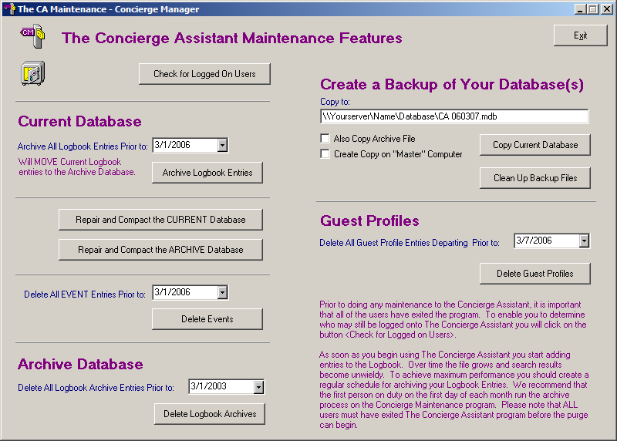

You will select the month, day and year that you want the entries deleted prior to from the calendar-combo box. Caution: Do not delete anything from the current calendar year!

You will then click on the button labeled “Delete Logbook Entries”.

When the deletion has completed, be sure to click on the “Repair and Compact the ARCHIVE Database” button and follow the prompts to complete this maintenance.

